20/20

Practice assessment

Group members:

1. ISHIMWE Jean Chrysostom
2. ASANUMUKIZA Noella
3. INEZA Talithakum
4. AINOMUGISHA Esther
5. UMUTONIWASE Liliane
6. UWIKIREZI Wivine
7. NIYIGENA Joshua
8. MBANZA Gad Prince
9. NGABONZIZA Nur
10. IHOGOZA Dolante
11. HIRWA Abijuru Bernon
12. UWIDUHAYE Henriette
13. RUSARO Gloria
14. UKWISHATSE Denyse

THE COMMANDS WE HAD USED

GIT CLONE: git clone help us to call repo from remote repo to local repo. This

Means we call it from github to local machine.

GIT STATUS: git status help us to review new changes on local repository

GIT ADD .: git add . help us to add changes from local repository to remote repository.

GIT COMMIT -M “”:git commit help us to commit changes from local repository to remote repository.

GIT PUSH: git push help us to push changes from local repo to remote repo.

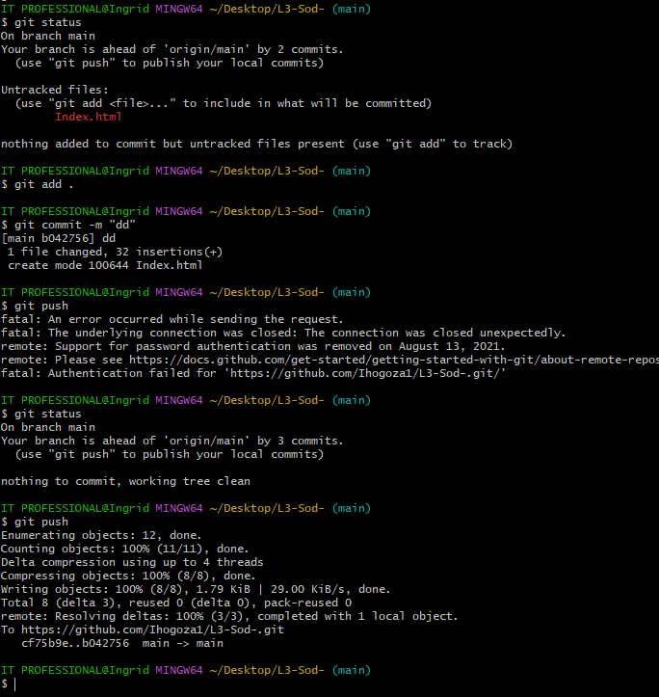

GIT PULL: git pull help us to pull changes from remote repo to local repo.

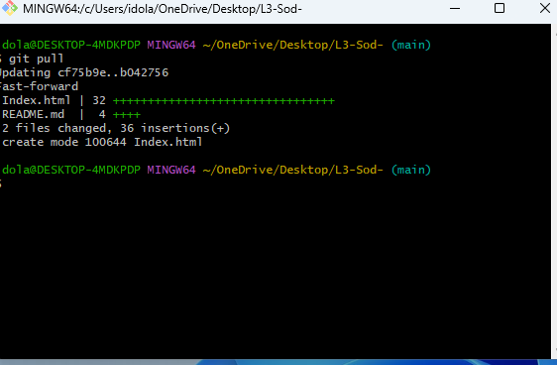

GIT FETCH: git fetch help us to review changes from remote repo without merging with the local repo

GIT LOG: git log help to review what we have been fetching.

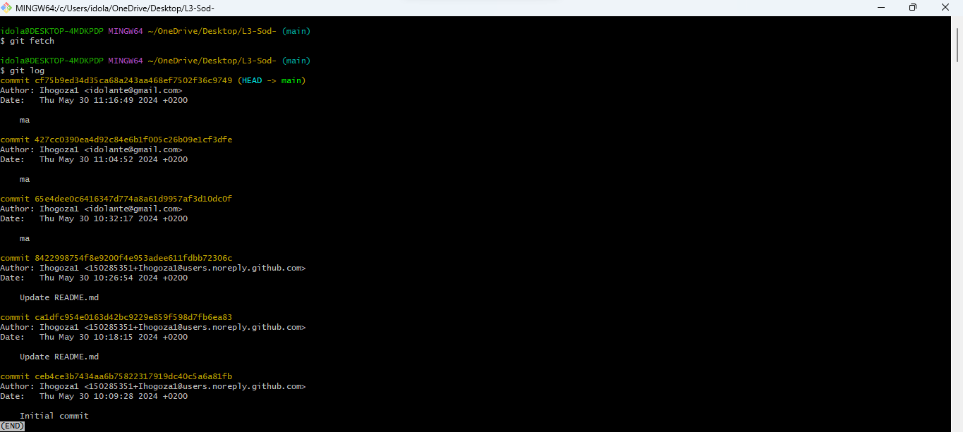

GIT PUSH --FORCE: git push --force help us to to push the changes that have conflict.

GIT FETCH --FORCE: git fetch --force help us to fetch the changes that has conflict.

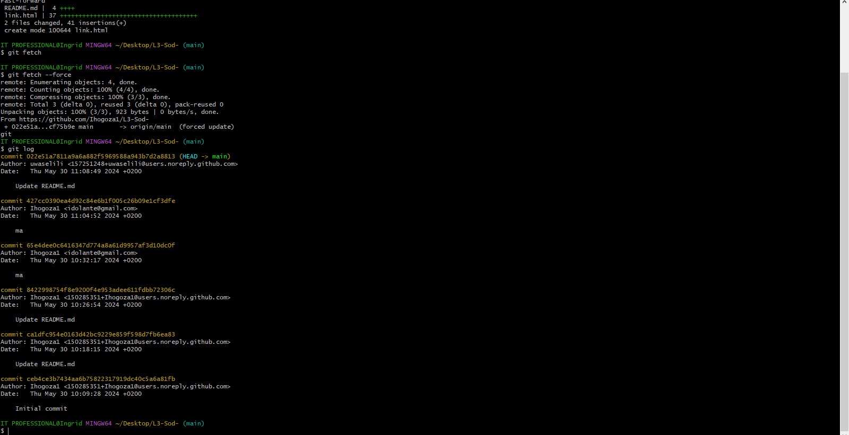

GIT PULL --FORCE: git pull --force help us to pull changes that have been pushed with conflict.

GIT CONFIG:

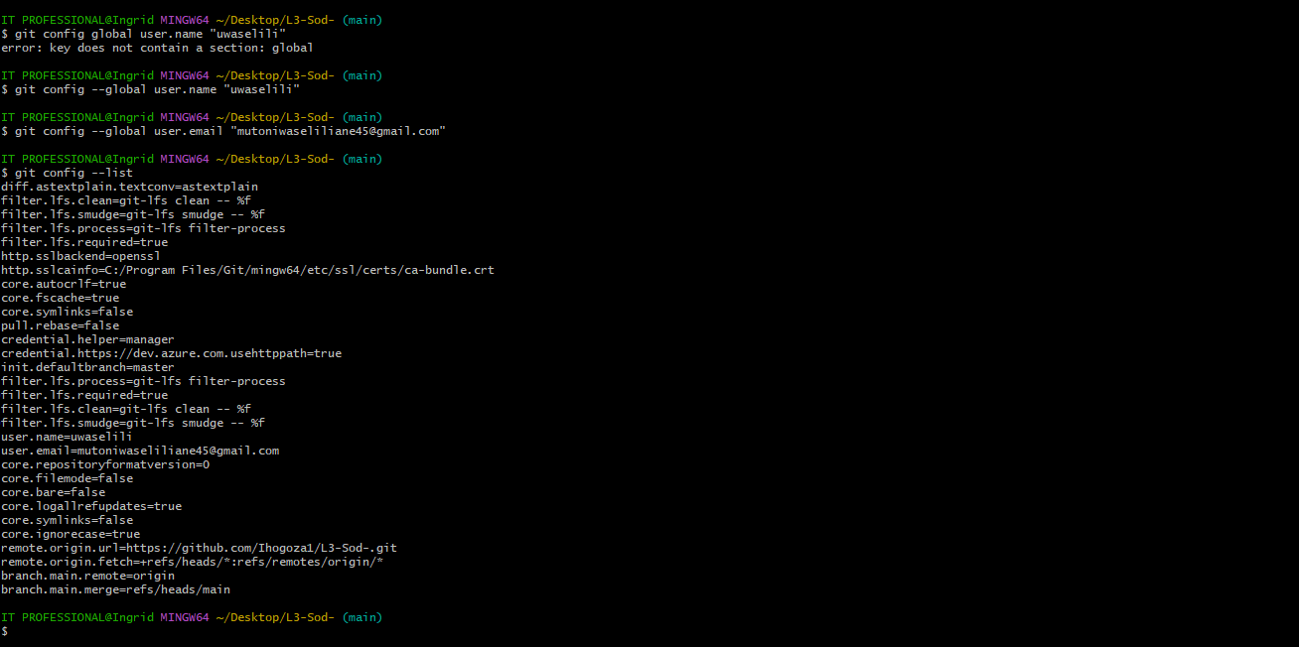

GIT CONFIG --LIST:

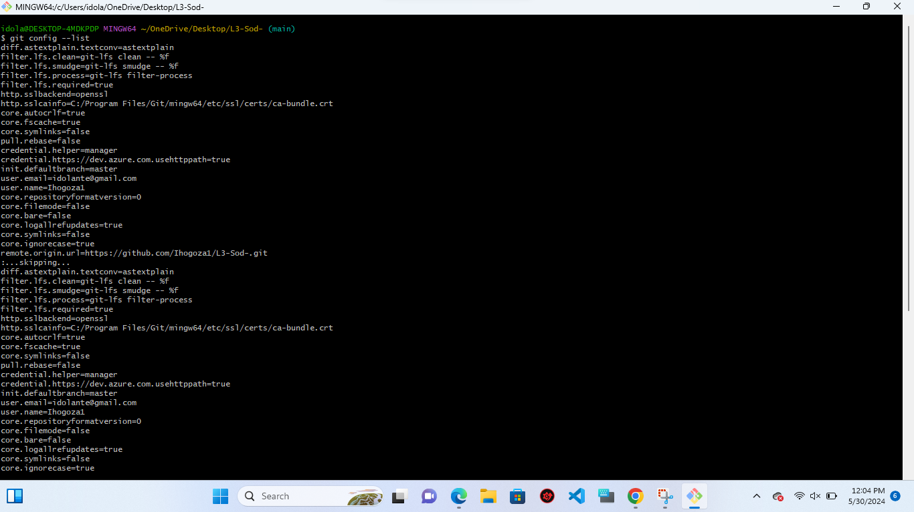

Checked by Trainer : Rurangwa Kevin